Equity swap and prime brokers

<https://www.reddit.com/r/Superstonk/comments/mobnyf/the_anatomy_of_an_equity_swap_how_prime_brokers/>

Client goes long

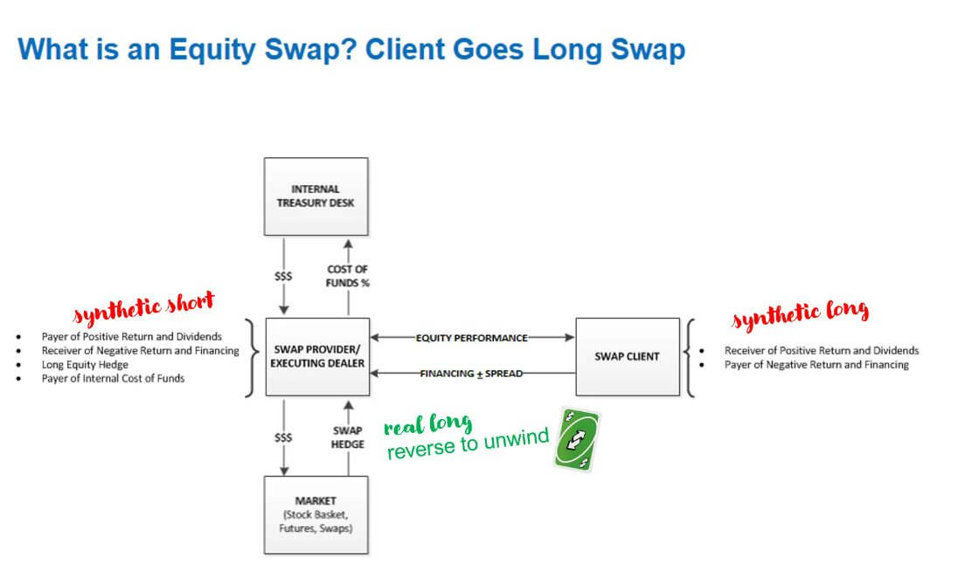

Client goes short

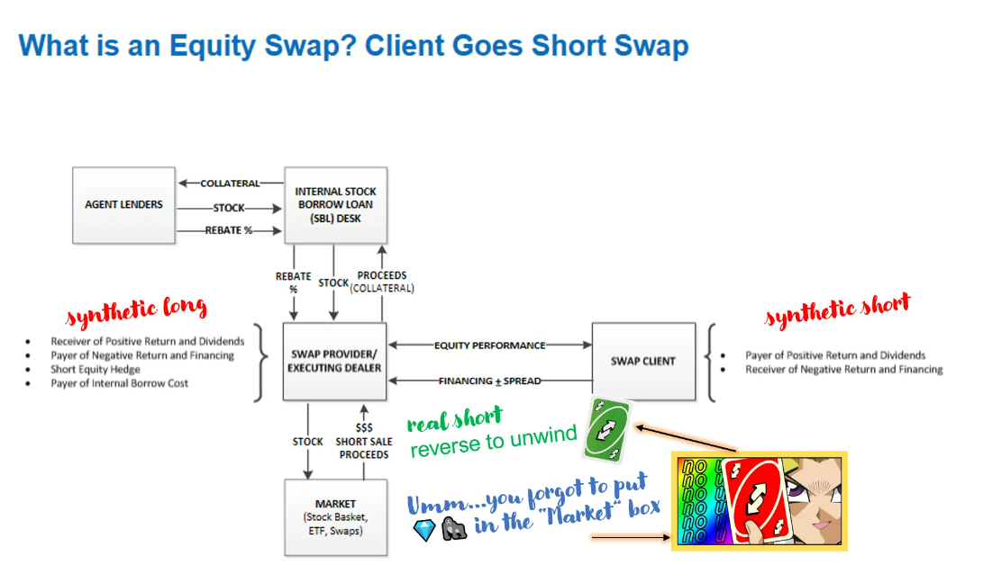

How do transactions flow:

Prime financing distribution desks, often part of prime brokerage divisions within larger financial institutions, handle a variety of transactions for hedge funds and other professional investors. These desks facilitate many types of transactions including securities lending, margin lending, equity swaps, and repurchase agreements (repos). Here's a simplified flow of how these transactions typically occur:

Client Request: The process usually starts with a request from a client. This could be a hedge fund, mutual fund, or another type of institutional investor. They might want to borrow securities for short selling, leverage their positions through margin lending, or enter into a derivative contract such as an equity swap.

Transaction Execution: The prime financing desk will then execute the transaction. If it's a securities lending transaction, for example, the desk will source the required securities from either their own inventory or from another client's account (with their permission), and then lend them to the borrowing client. The client will post collateral, typically cash or other securities, which is typically more than the value of the borrowed securities to manage the risk associated with the transaction.

Collateral Management: The prime broker will manage the collateral throughout the life of the transaction. In a securities lending transaction, for instance, they will mark the value of the borrowed securities and the collateral to market daily. If the value of the collateral falls below a certain threshold relative to the borrowed securities, the borrower will be required to post additional collateral.

Interest and Fees: The prime financing desk will charge interest and fees for the services they provide. In a securities lending transaction, the borrower will pay a borrow fee, which is a type of interest, for the duration of the loan. In an equity swap, the desk might charge a fee for structuring and executing the swap contract.

Transaction Unwinding or Maturing: Eventually, the transaction will either be unwound or reach maturity. In a securities lending transaction, the borrower will return the borrowed securities to the prime broker and their collateral will be returned to them. In an equity swap, the cash flows agreed upon in the contract will be exchanged and the contract will come to an end.

What I learned from:

Ask SBL for supply

ASK trader for prices

Execuation desk for execution